Media Kit

About Us: We are the local KC, MO (and surrounding suburbs) non-profit society of the American Dental Association. Gain exposure to our 500+ members including both general dentists and specialists while supporting organized dentistry.

Ways to Market Your Business with our Society:
* Insert advertisements in our publication,
the Midwestern Dentist News and Views.
We have seven issues annually and the magazines are printed and mailed to our membership as well as uploaded as pdfs on our website. Insertion and pricing information attached.
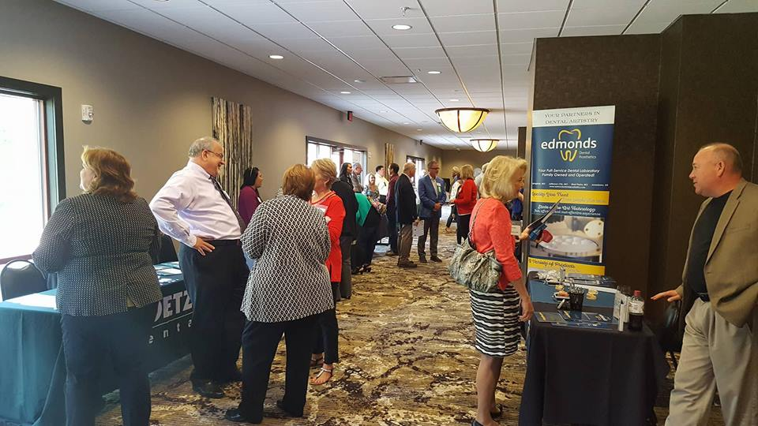

* Exhibit at our Continuing Education Programs.
We have seven local meetings annually that you can have a vendor table at to display your products and services to our attendees. For a premium level of support, you will have the opportunity to speak in front of the group for a few minutes. CE programs, exhibitor pricing and applications are attached.
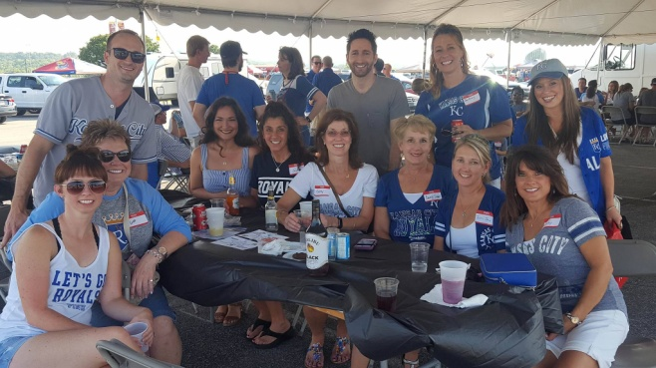
*Help sponsor our social events.
We have many fun membership events including Royals games tailgates, Top Golf and Chicken N Pickle new dentist events, KC Zoo family outings, and New Theatre nights. We also have student programs! Let us know if you'd like to be on our listserv for social event sponsorships and we'll email you as events are planned.

